The University of Azad Jammu and Kashmir, Muzaffarabad


Course: Computer Network
Course Code: CS-2203
Roll No: 2024-SE-13
Lab: 3
Submitted To: Engr. Asma Javaid
Submitted By: Sughra Mumshad
Date: 17 March, 2026

Department Of Software Engineering

Lab Report: Ethernet Cable Construction and Testing

1. Objective
The objective of this lab is to understand the Physical Layer of the OSI Model by creating a functional Ethernet cable using RJ45 connectors. The lab also aims to test the cable using a cable tester to verify proper connectivity. This activity helps in gaining practical knowledge of network cabling, wiring standards, and troubleshooting physical connections.

2. Introduction
The Physical Layer is the first layer of the OSI model and is responsible for transmitting raw data bits over a physical medium. It includes hardware components such as cables, connectors, and network interface devices.

Proper cable construction and termination are essential for:
Reliable data transmission
Minimizing signal loss
Ensuring stable network communication

In this lab, a UTP cable was terminated using RJ45 connectors on both ends following the T568B wiring standard, and its functionality was verified using a cable tester.

3. Equipment and Materials
The following tools and materials were used in this lab:

RJ45 connectors
UTP cable (Category 5 / Category 6)
Cable crimping tool
Cable tester
Packet Tracer / Networking Lab Setup
Digital camera (for documentation)

4. Theory
Ethernet cables are commonly used in LAN (Local Area Network) connections. The most widely used wiring standards are:

T568A
T568B

In this lab, the T568B standard was used, which arranges the wires in the following order:
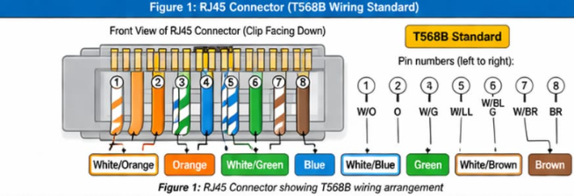
1. White/Orange
2. Orange
3. White/Green
4. Blue
5. White/Blue
6. Green
7. White/Brown
8. Brown
Correct alignment and proper crimping ensure that electrical signals are transmitted accurately between devices.
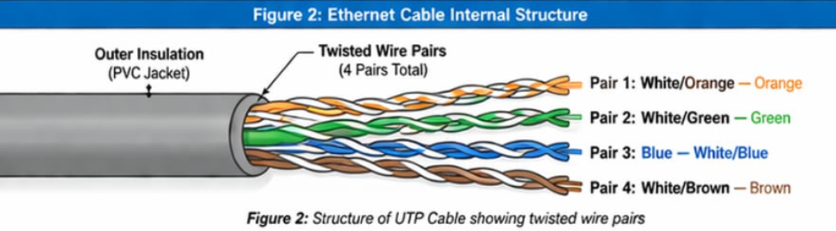

5. Procedure
The following steps were performed to complete the lab:

1. A UTP cable was cut to the required length.
2. The outer insulation of the cable was stripped to expose the internal wires.
3. The wires were untwisted and arranged according to the T568B standard.
4. The arranged wires were inserted carefully into the RJ45 connector.
5. A crimping tool was used to secure the connector firmly.
6. The same process was repeated for the other end of the cable.
7. The cable was connected to a cable tester.
8. The LED indicators on the tester were observed to verify connectivity.
9. Results were documented using photographs of the setup and tester output.
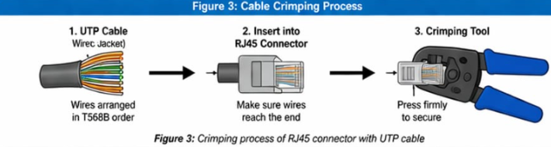

6. Observations
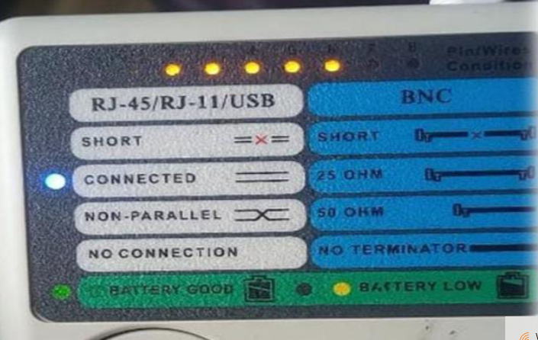

Most LED indicators on the cable tester were functioning correctly.
Proper connections were confirmed for several wire pairs.
One wire pair was not connected properly, indicating a wiring fault.

7. Results

Wire Pair Tester LED Status Remarks

1 – 2 ON Functioning
3 – 4 ON Functioning
5 – 6 ON Functioning
7 – 8 OFF Not Connected
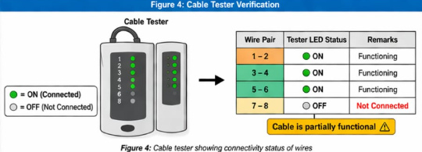

Result Summary:
The cable is partially functional due to improper connection in one wire pair.

8. Discussion
The results show that although most wires were correctly connected, one pair (7–8) failed. This could be due to:

Improper wire alignment
Incomplete insertion into the RJ45 connector
Weak crimping
Damaged wire
This highlights the importance of precision during cable termination.

9. Conclusion

This lab successfully demonstrated the working of the Physical Layer of the OSI model. By constructing and testing an Ethernet cable, we learned the importance of correct wiring standards and proper crimping techniques.

The experiment enhanced practical skills in:

Network cable construction
Fault detection
Troubleshooting physical connections
These skills are essential for real-world networking and system installation.

10. Recommendations

To improve results in future experiments:
Ensure wires are fully inserted into the RJ45 connector
Follow the wiring standard carefully
Use proper crimping pressure

